F. EXAMPLE PROJECTS WHICH BEST ILLUSTRATE PROPOSED TEAM’S QUALIFICATIONS FOR THIS CONTRACT  (Present as many projects as requested by the agency, or 10 projects, if not specified. Complete one Section F for each project.) |  |  |  |  |  |  | 20. EXAMPLE PROJECT KEY NUMBER  01
21. TITLE AND LOCATION (CITY AND STATE)  SR 210 Lane Addition and Baseline Interchange Project, San Bernardino and Redlands, CA |  |  |  | 22. YEAR COMPLETED
 |  |  |  | PROFESSIONAL SERVICES  2024 |  |  | CONSTRUCTION (IF APPLICABLE)
23. PROJECT OWNER’S INFORMATION
a. PROJECT OWNER  San Bernardino County Transportation Authority |  | b. POINT OF CONTACT NAME  Kristi Harris  Director of Project Delivery |  |  | c. POINT OF CONTACT TELEPHONE NUMBER  909.884.8276
24. BRIEF DESCRIPTION OF PROJECT AND RELEVANCE TO THIS CONTRACT (INCLUDE SCOPE, SIZE AND COST)
S2 Engineering was the program construction manager; this role required S2 to review, analyze, and report all claims issues, and scheduling issues to SBCTA in this $199 million construction project in San Bernardino and Redlands.

Construction Management
Construction Inspection
CPM Review and Analysis
Claims Analysis
Field Engineering and Support
Contract Change Orders negotiations and processing
Progress Pay Estimates
Review & approve Submittals and RFI’s
Project Controls and Contract Administration
PROJECT RELEVANCE
This 6.2-mile improvement project, completed in 2024, adds one mixed-flow lane in each direction between Highland Avenue and San Bernardino Avenue, auxiliary lanes (merge lanes) between Base Line and 5th Street, and an acceleration lane at the 5th Street eastbound ramp; it includes 22 bridge widenings including the multispan Santa Ana River and City Creek Bridges downstream of the Seven Oaks Dam. The project provides improved traffic flow, eliminates the bottleneck, provides lane continuity, and provides a smoother road surface throughout the corridor.
The pavement rehabilitation work, added through a cooperative agreement
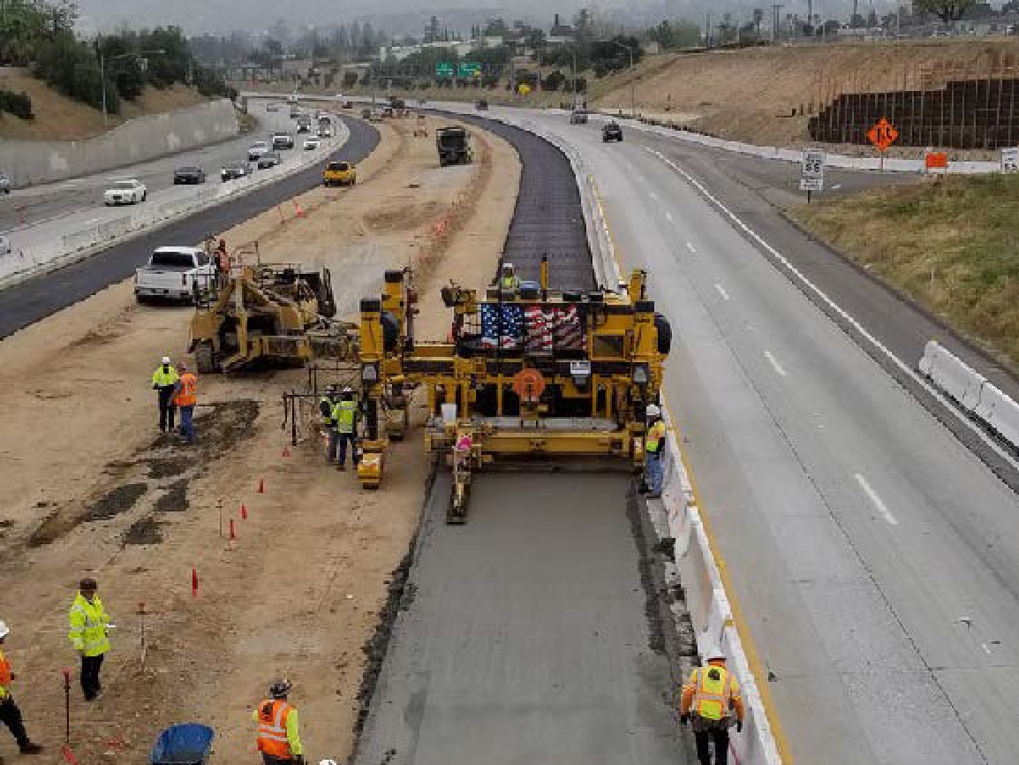
with Caltrans, includes slab replacement between Highland Avenue and 5th Street and new concrete pavement between 5th Street and Lugonia Avenue. Combining this with the other projects means one less project for
the community to navigate in the future.
Services included overall construction management, review and manage CM documents, review WSWD and controlling operations, review and analyze CPM Baseline and monthly update schedules, review all RFIs and submittals and responses, assuring timely disposition of correspondences, third-party coordination, review of disputes and potential claims documents, analysis of claims, preparation of claims report for SBCTA management use, negotiation with contractor to resolve claims issues based on the contract document.

25. FIRMS FROM SECTION C INVOLVED WITH THIS PROJECT
a. | S2 Engineering, Inc. |  | Rancho Cucamonga, CA |  |  | Construction Management / Claims Analyst / Scheduling
STANDARD FORM 330 (REV. 7/2021)

